Name:

Homeroom:

Subject Teacher:



Year 11

Unit 2 Economics Examination

Semester Two, 2018

Reading Time: 10 Minutes

Writing Time: 90 Minutes

|  |  |  |  |
| --- | --- | --- | --- |
| **Section** | **Number of Questions** | **No. of Questions to be answered** | **Number of Marks** |
| Section A: Multiple Choice | 25 | 25 | 25 marks |
| Section B: Growth & Sustainability | 3 | 3 | 21 marks |
| Section C: Efficiency & Equity | 4 | 4 | 25 marks |
| Section D: Globalisation | 2 | 2 | 10 marks |
|  |  | Total: | 80 marks |

|  |
| --- |
| /80 |

**Specific Subject Instructions:**

* Attempt all questions.

**Materials Allowed:**

* Pens, pencils, sharpener, eraser, highlighters and a ruler

|  |
| --- |
| Students are NOT permitted to bring mobile phones and / or any other electronic communication devices into the examination room. |

**SECTION A: MULTIPLE CHOICE (20 MARKS)**

**Question 1**

**Which of the following is not an injection into the circular flow of income?**

A. Investment

B. Exports

C. Savings

D. Government spending

**Use the following information to answer questions 2 and 3**

This scenario describes the total economic activity occurring in an economy: In Year 1, a dairy farmer produces milk, which she sells to the dairy processor for $100. The processor creates cheese, which she then sells for $200 to the retailer. The retailer sells the cheese to consumers for $400. In Year 2, assume that economic activity remains the same, except that the retailer now sells the cheese to consumers for $500.

**Question 2**

**Which of the following statements is false?**

A. The total value of production in Year 1 is $400

B. Gross National Income for the economy in Year 1 is $400

C. Real Gross Domestic Product for the economy in Year 1 is $400

D. Nominal Gross Domestic Product for the economy in Year 1 is $700

**Question 3**

**Identify the false statement from those below:**

A. The total value of production in Year 2 is $500

B. Real Gross Domestic Product for the economy in Year 2 is $500

C. Nominal Gross Domestic Product for the economy in Year 2 is $500

D. The growth rate of real GDP has been zero

**Question 4**

**Which of the following combinations are all examples of factors affecting aggregate supply?**

A. Productivity, costs of production, business confidence

B. Productivity, costs of production, interest rates

C. Consumer confidence, cost of inputs, climatic conditions

D. Business confidence, wage growth, company tax rates

**Question 5**

**If Australia was experiencing very low rates of economic growth (a downturn), it is likely**

A. the government would decrease budget spending and/or increase taxes, and the RBA would decrease the cash rate (interest rates).

B. the government would increase budget spending and/or cut taxes and the RBA would increase the cash rate (interest rates).

C. the government would decrease budget spending and/or increase taxes and the RBA would increase the cash rate (interest rates).

D. the government would increase budget spending and/or cut taxes, and the RBA would decrease the cash rate (interest rates).

**Question 6**

**Which of the following is not considered a factor contributing to economic globalisation?**

A. The desire of large businesses to take advantage of improved economies of scale

B. Improvements in transportation technologies, information technology and global communications

C. Recent decisions by some governments to restrict the flow of labour and trade, and favour local producers

D. Savings offered by differentials in wage rates across different countries

**Question 7**

**All of the following examples are likely to contribute to more environmentally sustainable economic growth, apart from**

A. households installing solar panels on their rooves.

B. government legislation to reduce the number of fishing licenses on issue.

C. introduction of a tax on carbon emissions.

D. government subsidies to coal-fired electricity generation.

**Question 8**

**In relation to the Lorenz curves shown in the diagram below, which of the following statements is false?**

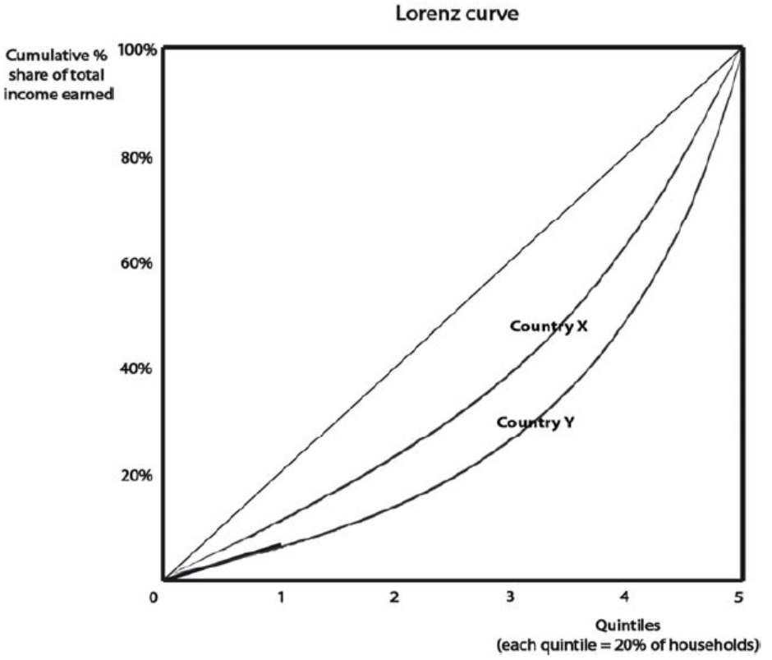

A. Country Y is likely to have a larger Gini coefficient than Country X

B. Country X is likely to have a more unequal distribution of wealth than Country Y

C. Country X has a more equal distribution of income than Country Y

D. Country X is likely to have a more progressive income tax system than Country Y

**Question 9**

**Which of the following factors is most likely to worsen equity in the distribution of equivalised household disposable income?**

A. The government introduces a tax on inheritances of over $1 million

B. The government increases funding for training for young, homeless people

C. The unemployment rate rises from 5.6% to 7%

D. The government removes excises (indirect taxes) on alcohol and petrol

**Question 10**

**Assume that the government reduced the top marginal income tax rate and increased the**

**GST rate. Which of the following would not be considered a benefit of such a policy?**

A. Increased tax receipts from all households, regardless of income

B. Increased productive efficiency due to rising productivity

C. Improved incentives for those on higher incomes to work harder

D. The ‘trickle down’ effect as businesses and wealthy individuals take more entrepreneurial risks

**Question 11**

**If economic growth is negative, overall living standards may still increase if**

A. nominal GDP per capita falls

B. there is increased access to health and education services

C. there is increased levels of pollution and environmental damage

D. population decreases by the same amount as economic growth

**Question 12**

**Of the following events, which is not likely to cause an increase in the aggregate demand for goods and services?**

A. A decrease in the value of the Australian dollar (depreciation of the exchange rate)

B. A decrease in interest rates

C. A decrease in income tax rates

D. A decrease in consumer confidence

**Question 13**

**The main cause of income inequality is**

A. Low income earners not receiving enough transfer income

B. Government provision of social welfare payments leading to people not working hard enough

C. Luck

D. Higher income earners having skills that get them higher paid jobs

**Question 14**

**Disposable income is defined as**

A. Private or market incomes plus direct cash benefits received from governments

B. Gross income less direct taxes plus indirect government benefits provided in the form of goods and social services

C. Gross income less the direct taxes levied by governments

D. Gross incomes less direct and indirect taxes plus indirect government benefits

**Question 15**

**The rate of economic growth in Australia is likely to fall in response to**

A. Higher commodity prices

B. A reduction in interest rates

C. A depreciation of the Australian dollar exchange rate

D. A reduction in the rate of economic growth in China

**Question 16**

**Which of the following is most likely to indicate an improvement in material living**

**standards?**

A. increased incidence of crime

B. increased carbon emissions per capita

C. increased real GDP per capita

D. increased nominal wages

**Question 17**

**An equitable distribution of income refers to**

A. each member of the economy receiving an equal share of total income

B. the way in which income is shared among the members of an economy

C. a distribution of income that allows everyone to receive sufficient income for a dignified life

D. the elimination of relative poverty

**Question 18**

**Examine the two D/S diagrams demonstrating different types of labour markets and choose the most correct statement.**

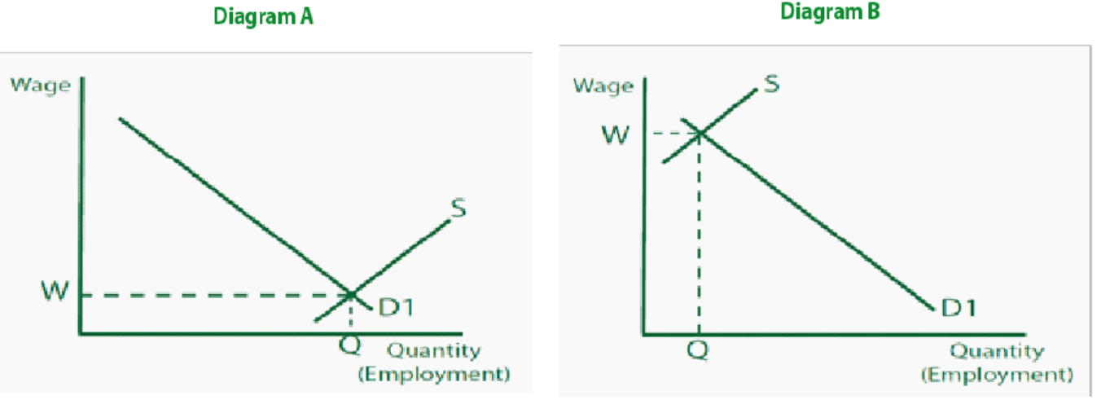

A. Diagram A shows a labour market where the supply of labour is low relative to demand, leading to low wages

B. Diagram A shows a labour market where the supply of labour is high relative to demand, leading to low wages

C. Diagram B shows a labour market where demand for labour is high relative to supply, leading to low wages

D. Diagram B shows a labour market where supply of labour is high relative to demand, leading to high wages

**Question 19**

**If Fairwork Australia were to reduce the minimum wage significantly, which of the following is the most likely result?**

A. A lower Gini coefficient

B. A movement outwards of the Lorenz curve

C. A more equal distribution of income

D. A decrease in absolute poverty

**Question 20**

**In relation to the Australian economy during 2017, which of the following statements is most accurate?**

A. Economic growth has been above 3%, inflation has been below 3% and the Australian dollar has ranged between 0.70USD and 0.80USD

B. Economic growth has been below 3%, inflation has been above 3% and the Australian dollar has ranged between 0.75USD and 0.85USD

C. Economic growth has been below 3%, inflation has been below 3% and the Australian dollar has ranged between 0.70USD and 0.80USD

D. Economic growth has been above 3%, inflation has been above 3% and the Australian dollar has ranged between 0.75USD and 0.85USD

**END OF SECTION A**

**SECTION B: SHORT ANSWER – ECONOMIC GROWTH & SUSTAINABILITY (20 MARKS)**

***Question 1 (9 marks)***

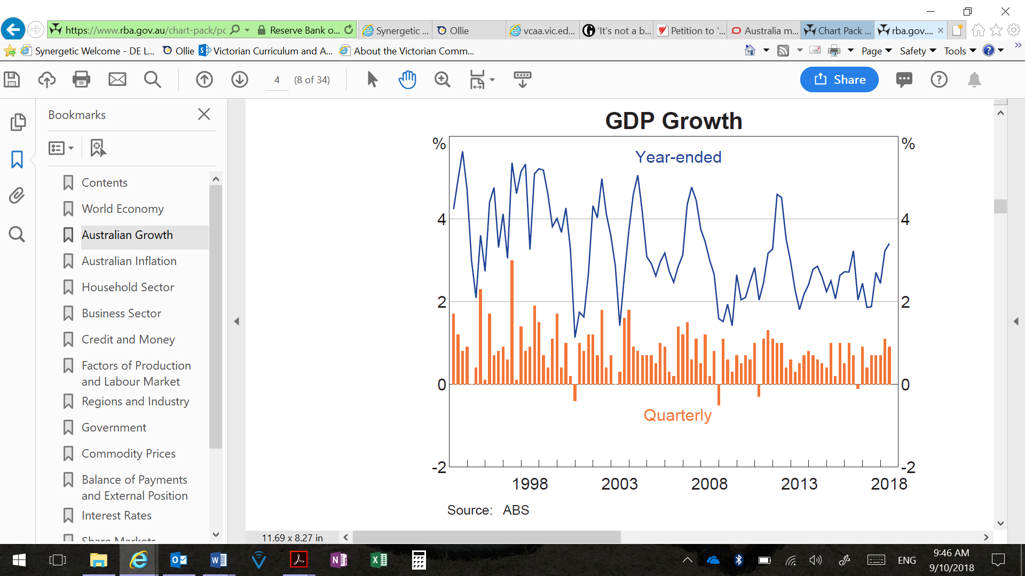

**a. Define economic growth and describe the overall trend in annual economic growth between the years 2017 – 2018. 2 marks**

Economic growth refers to the rate at which economic activity has grown over time and is most commonly determined by the change in the real value of output [production] from one year to the next. In the case of Australia, economic growth is measured by the change in real GDP - the value of all goods and services produced in Australia over a given period of time - compared to the previous period.

Between 2017 and 2018, annual economic growth trended upwards, from a low of 2% to a high of approximately 3.5%.

**b. Explain how the use of Monetary Policy has increased economic growth in 2018. 4 marks**

* The cash rate has remained unchanged at 1.5%
* Expansionary monetary policy stance.
* Increased household discretionary income and debt levels high – increased spending
* Increased economic growth (shown in graph in 1a).

**c. Explain why growth in real GDP per capita is used to measure improvements in material living standards and use data from Table 2 to respond to the claim that material living standards in Australia improved between 2013 and 2017. 3 marks**

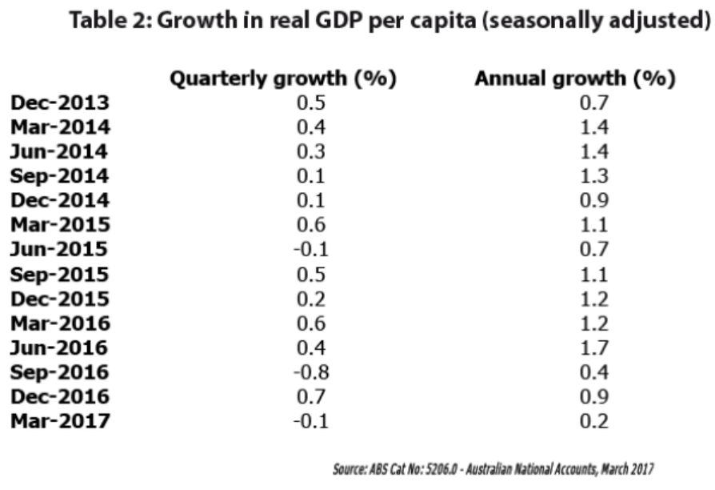

Growth in real GDP per capita refers to an increase in the real value of production of goods and services per person over time. The growth in real GDP per capita is used to measure improvements in material living standards because, when the value of production per person increases in real terms over time [after removing the effects of inflation], this leads to more employment opportunities and increased income, enabling the average person to purchase more goods and services from one year to the next. The data in Table 2 shows that annual growth in real GDP per capita has been consistently positive between 2013 and 2017, meaning that the level of material well-being in Australia is higher in 2017 compared to 2013. [Although real GDP per capita fell during three quarters between 2013 and 2017, overall, the consistent annual growth in real GDP per capita means that the real value of GDP per person in 2017 is greater than the real value of GDP per person in 2013.]

***Question 2 (6 marks)***

**Describe how the rate of economic growth is likely to be affected by each of the following economic events.**

**a. An increase in the Medicare levy from 2% to 2.5%, as proposed in Budget 2017/18. 2 marks**

The government increasing the Medicare levy to 2.5% would represent an increase in taxation rates for most taxpayers. This would decrease the disposable [after tax] income of most Australian households, reducing the willingness and ability of households to purchase goods and services, reducing Consumption and AD. As the business sector notices a reduction in spending there will be a reduction in output and economic growth.

**b. Appreciation of the Australian dollar exchange rate from 0.73USD in January to 0.79USD in August 2017. 2 marks**

As the Australian dollar appreciates relative to other currencies this results in Australia’s export sector (X) becoming less internationally competitive as overseas buyers need to exchange more of their currency to purchase the same quantity of our exports. [Furthermore, Australia’s import-competing sector will also face increased competition from relatively cheaper imported substitutes]. The Net Exports (X-M) component of AD will fall, leading to a decrease in AD and a deterioration in economic growth.

**c. An increase in the cash rate from 1.5% to 2%. 2 marks**

As the cash rate increases, this will most likely be reflected in an increase in interest rates from the big four banks. This would lead to a reduction in the consumption (C) and investment sector (I), as there will be a reduce willingness and ability of households to purchase goods and services, reducing AD and deteriorating economic growth.

***Question 3 (5 marks)***

**The South Australian Government has a target that 50 per cent of the state’s energy will be supplied from renewable sources by 2025. In mid-2017, it reported that 53 per cent of its energy has come from sun and wind-based sources. However, concerns over the sustainability of the network and interruptions to renewable energy generation (highlighted by a statewide blackout in late 2016) have prompted the South Australian Government to partner with Tesla to build the world’s largest battery to store energy from a nearby wind farm.**

**a. Explain why there is an inevitable trade-off between the pursuit of economic growth and environmental sustainability. 2 marks**

A trade-off refers to foregoing the opportunity to gain something of value with our resources, once those resources are used for some other purpose. The trade-off between pursuing economic growth and environmental sustainability occurs because when an economy or government pursues a growth strategy focused on increasing economic growth, it is unlikely that the environment can be maintained in its current form. A whole-hearted pursuit of economic growth can come at the cost of environmental sustainability - preserving our natural environment into the future by ensuring that current practices do not create environmental harm or deplete our natural resources.

**b. Explain how the use of one discretionary budgetary policy has impacted/will impact on strong economic growth. 3 marks**

1 mark for definition of discretionary stabiliser: A discretionary stabiliser is are deliberate policy decisions designed to change receipts or outlays in an effort to influence economic activity.

1 mark for reference to budget initiative: Lower Taxes to support growth/Roads of Strategic Importance. (Identify and describe)

1 mark for impact on AD/AS (Lower Taxes – Increase Investment (I), RoSI – Increase AS)

1 mark for increase in economic growth.

**END OF SECTION B**

**SECTION C: SHORT ANSWER – EQUITY & EFFICIENCY (25 MARKS)**

***Question 1 (13 marks)***

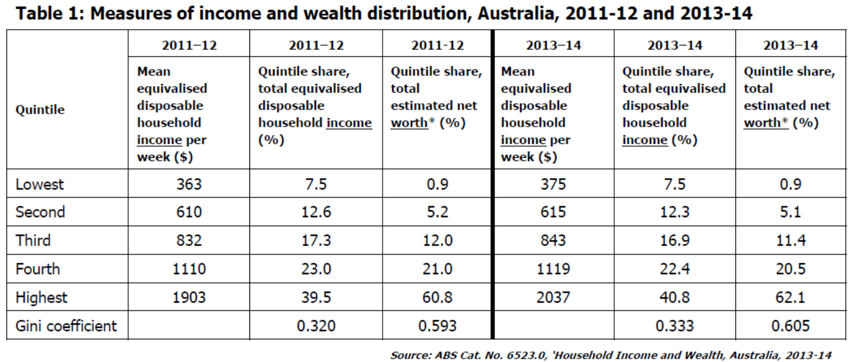

* The ABS uses ‘net worth’ to measure distribution of wealth in Australia. It refers to the value of all assets owned by a household (e.g. property owned outright) minus the value of all liabilities (e.g. debt owed on property).

**‘Reserve Bank governor, Philip Lowe, [said] inequality in Australia is getting worse. …**

**Speaking at an event supporting the Anika Foundation, he said the gap between the rich and poor has widened in recent years, but made the distinction between “wealth” and “income” inequality. … Dr Lowe said income inequality was also rising, but not as badly as wealth inequality. “Income inequality has drifted up a little but not very much,” he said.’**

Extract from: ‘RBA governor says inequality getting worse, contradicting Scott Morrison’, ABC online, 27th July 2017,

http://www.abc.net.au/news/2017-07-26/rba-says-inequality-getting-worse/8746594

**a. Define ‘income’ and ‘wealth’ and explain how wealth can increase income. 3 marks**

* 1 mark for defining income
* 1 mark for defining wealth
* 1 mark for explaining how wealth can be used to create income

**Sample answer:** Income is the money received by a household or other economic entity over a period of time and that is available to purchase goods and services. Income is a flow of money. On the other hand, wealth refers to the stock of assets held by a household or individual at a given point in time. If an individual has wealth this means that at some point in the past they have had income greater than their expenditure and have been able to put aside some of this income rather than spending it. This wealth can then be invested in income-generating assets such as property, shares or collectables, or simply deposited in a financial institution. Such assets then generate income in the form of rent, dividends, capital gains or interest.

**b. Discuss the RBA Governor’s claim that income inequality ‘has drifted up a little,’ but wealth inequality is much worse. Use data from Table 1 to support your answer. 4 marks**

* 0.5 mark for identifying that income inequality has increased slightly
* 0.5 mark for identifying that wealth inequality is much worse than income inequality
* 1.5 marks for supporting the claim of increasing income inequality with evidence from the table
* 1.5 marks for supporting the claim of high levels of wealth inequality with evidence from the table

**Sample answer:** The RBA governor is correct in observing that income inequality has increased slightly over time, but that income distribution is much less unequal than the distribution of wealth in Australia. The data in Table 1 supports both of Dr Lowe’s claims. The Gini coefficient is a measure of income inequality, where a Gini coefficient of zero indicates that all income earners receive the same share of income. As the Gini coefficient moves closer to 1, income inequality increases. Given that the Gini coefficient for distribution of [equivalised disposable household] income increased from 0.320 in 2011-12 to 0.330 in 2013-14, it indicates that income inequality has worsened (or increased).

On the other hand, wealth inequality, while not increasing rapidly, is much more extreme than income inequality in Australia. The Gini coefficient for net worth [the ABS’ measure of wealth] was 0.605 in 2013-14, compared to 0.593 in 2011-12. Furthermore, in 2013-14, the share of wealth owned by the top 20% of households was 62.1%, compared to only 0.9% held by the lowest 20% of households. This indicates that, as Dr Lowe stated, the gap between rich and poor has widened in recent years and that wealth was much more unequally distributed than income [as evidenced by the much larger Gini coefficient for wealth (0.6) compared to income to income (0.33).

**c. Explain the likely impact on the distribution of income of the following government budgetary policy decisions: 6 marks**

**i. Increased spending on training and education.**

Increased spending on training and education can help to improve the skills and employability of the long-term or hard-core unemployed. To the extent that this spending meets gaps in education or improves out-of-date skills, individuals who are currently unemployed [or underemployed] may be able to gain [further] paid employment. There will be a reduction in the level of inequality in income distribution as these individuals move from low transfer payments [such as pensions or unemployment benefits] to higher factor incomes [e.g. wages and salaries].

**ii. An increase in the GST rate from 10% to 12.5%.**

The GST is an indirect, regressive tax currently levied at a fixed rate of 10% on the purchase of most goods and services. If the government increases the GST rate to 15% this will impact most heavily on those on lower incomes. This is because the flat rate tax of 15% of the purchase price on each item would represent a larger proportion of the income of a low-income earner compared to a high income earner. Hence, low-income earners will be paying a larger percentage of their income on the tax and worsening equity in the distribution of income.

**iii. Application of stricter requirements to welfare payments.**

Harsher requirements to meet the criteria to receive welfare payments will negatively impact low income earners. This is because less low income earners will be able to receive welfare payments and less money will be allocated from high income earners taxable income. Hence, there will be a reduction in the level of inequity of income distribution as more individuals don’t meet the requirements.

**Question 2 (6 marks)**

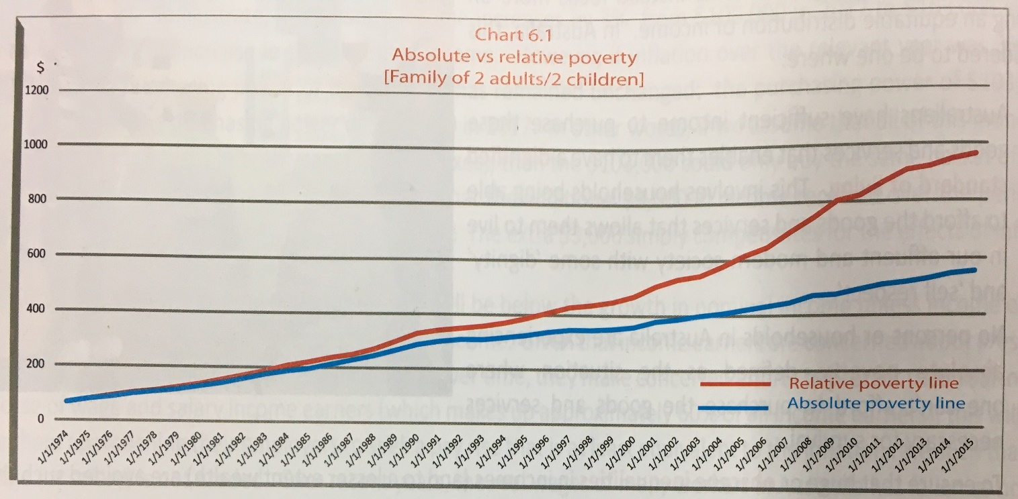

**a. Explain the difference between ‘absolute’ and ‘relative’ poverty. In your answer, make use of the data presented in the above chart. 3 marks**

Absolute poverty refers to a person living in a situation where they have insufficient income to purchase the basic goods and services such as food, shelter and housing. In contrast, relative poverty occurs when a person or household has a low level of income compared to a generally agreed standard.

The data presented in Table 2 refers to the Henderson poverty line, which is the measure of ‘relative’ poverty in Australia. As shown in the table, the poverty line refers to the level of income that household needs to be earning above in order to be living ‘above the poverty line’. For example, a household made up of a two adults (a couple) and two children, where at least one of the parents is in the workforce would need to be receiving at least $821.22 per week, after income tax, or they would be living in ‘relative poverty’. The Henderson poverty line is a fixed proportion of the average household disposable income, and it has risen over time as Australia’s income and wealth has increased.

**b. Outline how poverty can impact living standards, and explain one action the government can take to help reduce poverty. 3 marks**

Poverty (whether absolute or relative) is typically associated with poor outcomes for health and education of those family members living in poverty. Children living in poverty are less likely to be engaged at school, resulting in lower skill levels and an increased likelihood of being unemployed as an adult.

One action the government can take to help reduce poverty is to provide non-cash benefits to lower income households. These non-cash benefits can include subsidised housing, transport and health concessions, and energy rebates. The provision of these non-cash benefits mean low-income households are able to use the income they do have to purchase other goods and services that may enhance their quality of life and standard of living. It also means that more households in Australia will be able to avoid absolute poverty.

**Question 3 (3 marks)**

**Australia has a ‘progressive income tax system’, where the proportion of income paid in tax increases as income increases.**

**Explain how a decision by the government to increase the top tax rate paid by high-income earners illustrates the potential conflict between improving efficiency and improving equity in income distribution.**

A progressive income tax system is one method used by the Australian Government to help improve equity in income distribution. Under a progressive income tax system, the proportion of income paid as tax increases as one’s income increases. Increasing the top tax rate paid by high-income earners means that high-income earners will pay significantly more income tax than low-income earners, so that the majority of the tax burden falls on those who have the greatest capacity to pay. This type of tax system works to effectively redistribute income from high to low-income earners and having means that income distribution in Australia becomes less unequal after income tax is paid. In addition, any additional revenue collected by increasing the top marginal income tax rate could be used to provide income support and other services-in-kind to support low-income earners.

However, since such an increase will mean that high-income earners will have to pay a larger proportion of their income in tax, it may discourage productive (or entrepreneurial) effort. If the highest marginal tax rate is increased, this will mean that for each extra dollar earned, perhaps as a result of seeking a promotion or undertaking a more challenging role, a high-income earner will receive back less income after tax. Since extra effort and work intensity can help drive productivity growth in the economy, raising marginal tax rates for high-income earners can stifle productivity growth and reduce (productive) efficiency.

**Question 4 (3 marks)**

**The government imposes excise taxes on some goods considered harmful, such as tobacco, alcohol and petrol. For the next four years, the government will increase tobacco excise by**

**12.5% each September.**

**Explain how the increase in tobacco excise could improve efficiency in allocation of resources while at the same time reducing equity in the distribution of income.**

* 1.5 mark for explaining how increasing the excise improves allocative efficiency
* 1.5 mark for explaining how increasing the excise can worsen equity

**Sample answer:** Imposing high (and increasing) excises on tobacco is intended to send a price signal (raising the price of the product) that discourages consumption and therefore reduces the harm caused by tobacco consumption. The resources previously allocated to production and consumption of demerit goods like tobacco would then be available to be reallocated to purposes that are better for society, improving the level of allocative efficiency (where resources are allocated to produce goods and services that provide the maximum possible benefits to society.)

However, excises such as those on tobacco are regressive taxes. These are taxes that collect proportionally more of a lower income earner’s income compared to the proportion of tax collected from a higher income earner’s income. Because the excise is paid as a percentage of the price of the product, everyone who purchases tobacco products, such as cigarettes, pays the same amount of excise per item, regardless of their level of income. This means that the amount of tax (excise) paid represents a larger proportion of a low-income earner’s income than that of a high-income earner’s income. These taxes can reduce equity in the distribution of income, as they impact more heavily on those on lower incomes.

[On the other hand, it could also be argued that if the high rate of excise sends a price signal that discourages low-income earners from purchasing the product this could improve equity in income distribution, since it will leave them with more income to dedicate to purchasing other less harmful products.]

**END OF SECTION C**

**SECTION D: SHORT ANSWER – FREE TRADE VS PROTECTIONISM (10 MARKS)**

**Question 1 (10 marks)**

**Australia may be engaging in ‘free trade’ but it’s becoming more protectionist too**

February 20, 2018 4.51pm AEDT

The federal government may be [aggressively](http://dfat.gov.au/trade/agreements/Pages/status-of-fta-negotiations.aspx) negotiating free trade agreements, but in other ways it is [restricting trade](http://www.afr.com/news/economy/trade/how-malcolm-turnbull-is-quietly-apeing-donald-trump-on-trade-20180216-h0w6zw). The government has been giving itself extensive new anti-dumping powers, targeting [steel and aluminium markets](https://industry.gov.au/industry/IndustryInitiatives/TradePolicies/Pages/default.aspx) in particular.

There was a [nearly two-fold](https://www.wto.org/english/news_e/news17_e/g20_wto_report_june17_e.pdf) increase in anti-dumping investigations in Australia in 2017. According to the [Productivity Commission](https://www.pc.gov.au/research/completed/rising-protectionism/rising-protectionism.pdf), these protectionist measures “raise costs to consumers and reduce competitive pressures, leading to less efficient resource use in the country levying the protection”.

Higher tariffs lift the costs of imports and disrupt global supply chains. This harms consumers, producers and workers.

The Productivity Commission [estimates](https://www.pc.gov.au/news-media/pc-news/pc-news-august-2017/rising-protectionism) that for every A$1 increase in tariff revenue, economic activity in Australia falls by A$0.64. The commission also says that for **“every year that higher tariffs prevailed, GDP would be lower by over one per cent”**. Thus, **“a household that spends A$2,500 a fortnight on goods and services would be worse off by A$100 a fortnight”.**

The [Australian Department of Industry](https://www.aph.gov.au/~/media/02%20Parliamentary%20Business/24%20Committees/243%20Reps%20Committees/AgInd/AntiDumping/02%20Chapter%202%20-%20anti-dumping%20framework.pdf?la=en) explains that: dumping occurs when goods exported to Australia are priced lower than their “normal value”, which is usually the comparable price in the ordinary course of trade in the exporter’s domestic market.

A recent example of this in action was when the [Anti-Dumping Commission found](http://www.adcommission.gov.au/cases/EPR%20351%20%20450/EPR%20443/005%20-%20Notice%20-%20ADN%202018-25%20-%20Notice%20for%20longer%20period%20for%20the%20decision.pdf) that major exporters of tinned Italian tomatoes were dumping their product in Australia. The government swiftly imposed [dumping duties of up to 8.4%](http://www.smh.com.au/business/consumer-affairs/all-italian-tomato-exporters-to-australia-slapped-with-antidumping-measures-20160211-gmrcor.html).

In principle, this is perfectly legitimate. [World Trade Organisation agreements](https://www.wto.org/english/thewto_e/whatis_e/tif_e/agrm8_e.htm) allow these duties to be imposed when dumping or subsidisation threaten to cause material injury to a domestic industry.

1. **Define free trade. 2 marks**

Means that nations can engage in international trade without facing protection or trade barriers. This means that trade policies such as tariffs (tax on imported goods), quotas (volume restrictions).

1. **Referring to the article, explain the benefits of free trade over protectionism. 4 marks**

By shielding local producers from competition, protection reduces the incentive to be efficient.

Assuming the protected industry is a producer goods industry (producing goods that are inputs in the production process), protection raises input costs, increases and reduces competitiveness of other producers.

Protection can contribute to inflationary pressure both in the short run (via higher import prices through tariffs) and longer term (via a reduction in efficiency and an erosion of competitiveness).

Inflationary impact of higher tariffs or quotas will tend to cause a depreciation of the AUD. This can penalise some Australian producers who rely on imported capital equipment in the production of goods.

1. **According to the article, there are benefits to protectionism particularly with regards to dumping. Explain the reasons why the Australian Government felt the need to implement anti-dumping legislation in 2018. 4 marks**

Dumping occurs when goods exported to Australia are priced lower than their "normal value" which is usually the comparable price in the ordinary course of trade in the exporter's domestic market. Anti-dumping is the imposition of a measure by the Australian government, in the form of an additional duty on imports and/or a minimum export price, to remedy material injury to Australian manufacturers caused by dumping.

**END OF SECTION D**